|  |  |  |
| --- | --- | --- |
| **Discern**  By the end of this unit of study, pupils will be able to talk and think creatively and critically about what they have studied, for example, through: | | |
| D2.2.1 | Talking about Isaiah’s picture language about light and darkness (Is 9:1-2) and making simple links with Jesus. |  |
| D2.2.2 | Saying what they wonder about the Holy Spirit and how baby John the Baptist, Mary, Elizabeth, and Zechariah felt. |  |
| D2.2.3 | Talking about how other cultures and communities prepare in Advent, for example, through art, dance, music, or celebrations such as Las Posadas. (RVE) |  |
| D2.2.4 | Listening to different traditions and interpretations of the meaning of the Advent wreath. (RVE) |  |
| **Respond**  During this unit of study, pupils will be invited to respond to their learning, for example by: | | |
| R2.2.1 | Talking about Mary’s prayer, the Magnificat (Lk 1:46-50, 53) and how they can make the world fairer. For example, how they could fill the hungry with good things in Advent147 or what choices they could make in Advent to support local and global communities in need and to care for Creation (CST). (RVE) |  |
| R2.2.2 | Using artistic expressions to create a personal response to Isaiah’s picture language about light and darkness (Is 9:1-2). |  |

|  |  |  |
| --- | --- | --- |
| **Understand**  By the end of this unit of study, pupils will be able to: | | |
| U2.2.1 | Retell, with increasing detail, one of the religious accounts from the Annunciation and the birth of John the Baptist and of the Annunciation and the birth of Jesus from the Gospel of Luke. |  |
| U2.2.2 | Know that a prophet or prophetess communicates God’s message, inspired by the Holy Spirit, and that Isaiah and John the Baptist are prophets. |  |
| U2.2.3 | Identify Zechariah’s special message about John’s future (Lk 1:76). |  |
| U2.2.4 | Recognise that the Church teaches that the person Isaiah spoke of was Jesus long before he was born. |  |
| U2.2.5 | Recognise that the Church teaches that Mary is the mother of God who prays for them and with them. |  |
| U2.2.6 | Describe some ways that Christians prepare for Jesus’ coming at Christmas during the season of Advent for example, correctly using religious words and phrases to recognise the meaning given to the Advent wreath and how these might help Christians prepare for Christmas. (RVE) |  |

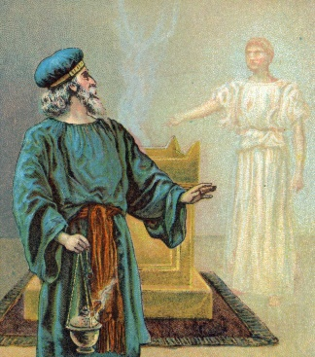

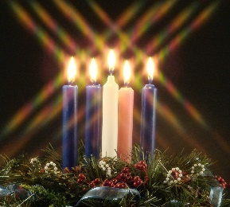

**Key Vocabulary**

Advent Advent wreath

Annunciation Isaiah

Magnificat John the Baptist

Prophet Zechariah