|  |  |  |
| --- | --- | --- |
| **Discern**  By the end of this unit of study, pupils will be able to talk and think creatively and critically about what they have studied, for example, through: | | |
| D1.2.1 | Talking about why the shepherds saw angels when Jesus was born. |  |
| D1.2.2 | Thinking about why the words of the angels are in the ‘Hail Mary’ and the beginning of the ‘Gloria’. |  |
| D1.2.3 | Exploring artistic representations of the nativity story from around the world. (RVE) |  |
| **Respond**  During this unit of study, pupils will be invited to respond to their learning, for example by: | | |
| R1.2.1 | Hearing and beginning to join in with the words of the Hail Mary. |  |
| R1.2.2 | Singing or saying the first words of the Gloria. |  |
| R1.2.3 | Talking about how Christians in their local community celebrate the birth of Jesus. (RVE) |  |

|  |  |  |
| --- | --- | --- |
| **Understand**  By the end of this unit of study, pupils will be able to: | | |
| U1.2.1 | Recognise that, for Christians, the Christmas story reveals God’s love by sending Jesus his Son. |  |
| U1.2.2 | Be introduced to the Bible as a special book and encounter the stories and accounts of how people came to know God and the Good News of Jesus in the gospels. |  |
| U1.2.3 | Sequence the accounts from the Annunciation through to the visit of the shepherds. |  |
| U1.2.4 | Know that in the Annunciation God called Mary and she said ‘Yes’ to his call and why this makes Mary important for Christians. |  |
| U1.2.5 | Match the first words of the Hail Mary with the words of the Angel Gabriel. |  |
| U1.2.6 | Recognise that angels bring God’s message and are a sign that Jesus is the Son of God |  |

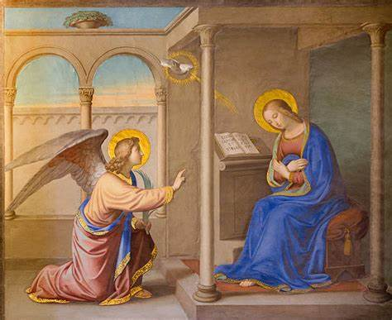

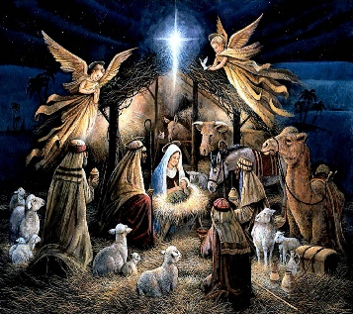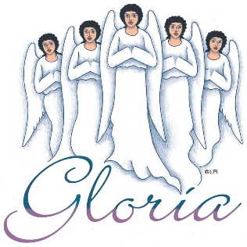

**Key Vocabulary**

Jesus Bible

Annunciation angels Visitation

Hail Mary Gloria

Our Father Creed